The National University of Lesotho
Department of Mathematics and Computer Science
Faculty of Science and Technology

CS4430: Distributed Database Systems
CENTRALIZED DATABASE DESIGN
Coordinator: Mr. Khobatha Setetemela
Due: 29th March 2026

Team Members
Student Number Name

200900706  202201934  202201176  202201173  202200990  202201992  202201955  202201074 | Moleleki H.G.  Nkolokoane L.N.  Mohlapisi B.I.  Ramochele M.B.  Motaung M.  Makoetje K.G.M.  Leiee L.J.  Ramainoane M.A.R.

BorderFlow: Centralized Database Design

1. Introduction
This document outlines the centralized database design for the BorderFlow system. As mandated by the project requirements, we begin with a normalized, centralized model. This design captures all core entities, their relationships, and the critical business rules that govern container logistics.

2. Entity-Relationship Diagram (ERD)
The ERD is described below, outlining the core entities and their relationships.
- Client: Represents a customer or organization that owns the consignment.
- Site: Represents a logical operational location (e.g., Maseru Depot, Maseru Bridge Border Post). Each site has a site_type (DEPOT, BORDER, PORT, HUB).
- Driver: Represents a truck driver. A driver is assigned to a Vehicle.
- Vehicle: Represents a truck used to transport containers. It can be assigned to one Driver at a time.
- Container: The physical asset being tracked. Each container has a unique global identifier.
- Consignment: The business entity linking a Container to a Client for a specific journey. It defines the start and end locations.
- Trip: The operational execution of a consignment. A Consignment can have multiple Trips (e.g., if it's handed over to different drivers or vehicles). A Trip has a status (PLANNED, ACTIVE, COMPLETED).
- Assignment: The junction linking a Trip, a Vehicle, and a Driver. This prevents double-booking of resources.
Milestone: A key event in the lifecycle of a Trip or Consignment. Each Milestone has a milestone_type (e.g., GATE_IN, GATE_OUT, CUSTOMS_CLEARED, VESSEL_LOADED, DELIVERED) and is associated with a Site.

Incident: Records any exception or noteworthy event (e.g., seal broken, customs hold, delay). An incident is link-ed to a Trip and/or Container.

4. Key Rules and Invariants
These rules define the logical consistency of the system. The distributed design must enforce these invariants, either immediately (when online) or eventually (after conflict resolution).

1. Container Uniqueness and Status:
- Invariant: A container_number must be globally unique.
- Rule: A Container cannot be assigned to a new Consignment if its current status is IN_TRANSIT. It must be AVAILABLE or DELIVERED.

2. Driver and Vehicle Assignment:
- Invariant: A Driver or Vehicle cannot be assigned to two active trips at the same time.
- Rule: Before a new Assignment is created for an ACTIVE Trip, the system must verify that the driver_id and vehicle_id are not currently assigned to any other ACTIVE trip where assignment.unassigned_at is NULL.

3. Consignment and Trip Lineage:
- Invariant: A Consignment must have at least one Trip.
- Rule: When a Consignment is created, a corresponding Trip (with status PLANNED) must be created to represent its first leg of movement.

4. Milestone Sequencing:
- Invariant: Milestones for a Trip must occur in a logical order.
- Rule: A GATE_OUT milestone cannot be recorded without a preceding GATE_IN milestone for the same Trip at a depot.
- Rule: A DELIVERED milestone marks the end of a Trip and Consignment. No further milestones should be recorded for that Trip or Consignment after this point.

5. Auditability:
- Invariant: All state changes to a Container (e.g., status change, location) must be derived from a recorded Milestone.
- Rule: The system must be able to reconstruct the history of a container by reading the Consignment -> Trip -> Milestone chain.

6. Consignment Completion:
- Invariant: A Consignment can only be marked as complete (end_date populated) after its associated Trip(s) have a final DELIVERED milestone.
- Rule: The consignment.end_date should automatically be set to the timestamp of the final DELIVERED milestone for the last Trip in the chain.

7. Incident Integrity:
- Invariant: An Incident must be linked to either a Trip or a Container (or both).
- Rule: If an incident is linked to a Trip, the trip_id must be valid and active at the time of the incident

Database Schema
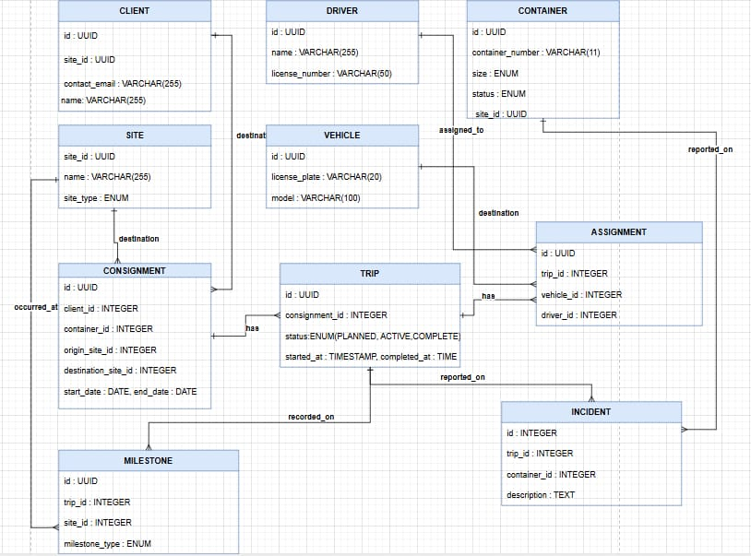

BorderFlow Database Schema
Normalized Database Design (3NF)
